RESOLUTION NO.__________

RE: CERTIFICATE OF APPROPRIATENESS UNDER THE
PROVISIONS OF THE ACT OF THE PENNSYLVANIA
LEGISLATURE 1961, JUNE 13, P.L. 282 (53
SECTION 8004) AND BETHLEHEM ORDINANCE NO.
3952 AS AMENDED.

WHEREAS, it is proposed to install signs at 201 E. Third Street

NOW, THEREFORE, BE IT RESOLVED by the Council of the City of Bethlehem that a Certificate of Appropriateness is hereby granted for the work.

Sponsored by: (s)

(s)

ADOPTED BY COUNCIL THIS DAY OF

(s)
President of Council

ATTEST:

(s)
City Clerk

HISTORIC CONSERVATION COMMISSION

CASE # 631– It is proposed to install signs at 201 E. Third Street
OWNER/APPLICANT: East Third St, LLP / Terrence Burns

The Commission upon motion by Mr. Evans seconded by Mr. Traupman adopted the proposal that City Council issue a Certificate of Appropriateness for the proposed work described herein:
- The proposal to install signs at 201 E. Third Street was represented by Terrence Burns

- The new fascia signs will read “Hot Plate Soul Kitchen” and will be painted in the existing painted sign areas facing Third St. and Webster St. The existing borders and background will remain and the existing tan background color will be repainted to cover the existing lettering.

- The fascia signs will match part of the proposed window sign with Hot Plate in blue above Soul Kitchen in red. The size of the sign will be adjusted to have about 2”-3” of background between the letters and the existing green border

- Vinyl lettering with circular logo will be installed on the front window facing Third St. The design of the sign will match the rendering submitted to the Commission at the meeting.

- The vinyl sign will have a white background behind the lettering, and the lettering will be the same for the vinyl sign and the fascia signs.
- The motion to approve the proposed work was unanimously approved.

CU: cu
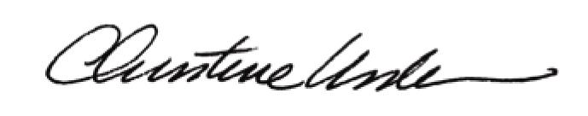

By:

Date of Meeting: November 20, 2017 Title: Historic Officer

